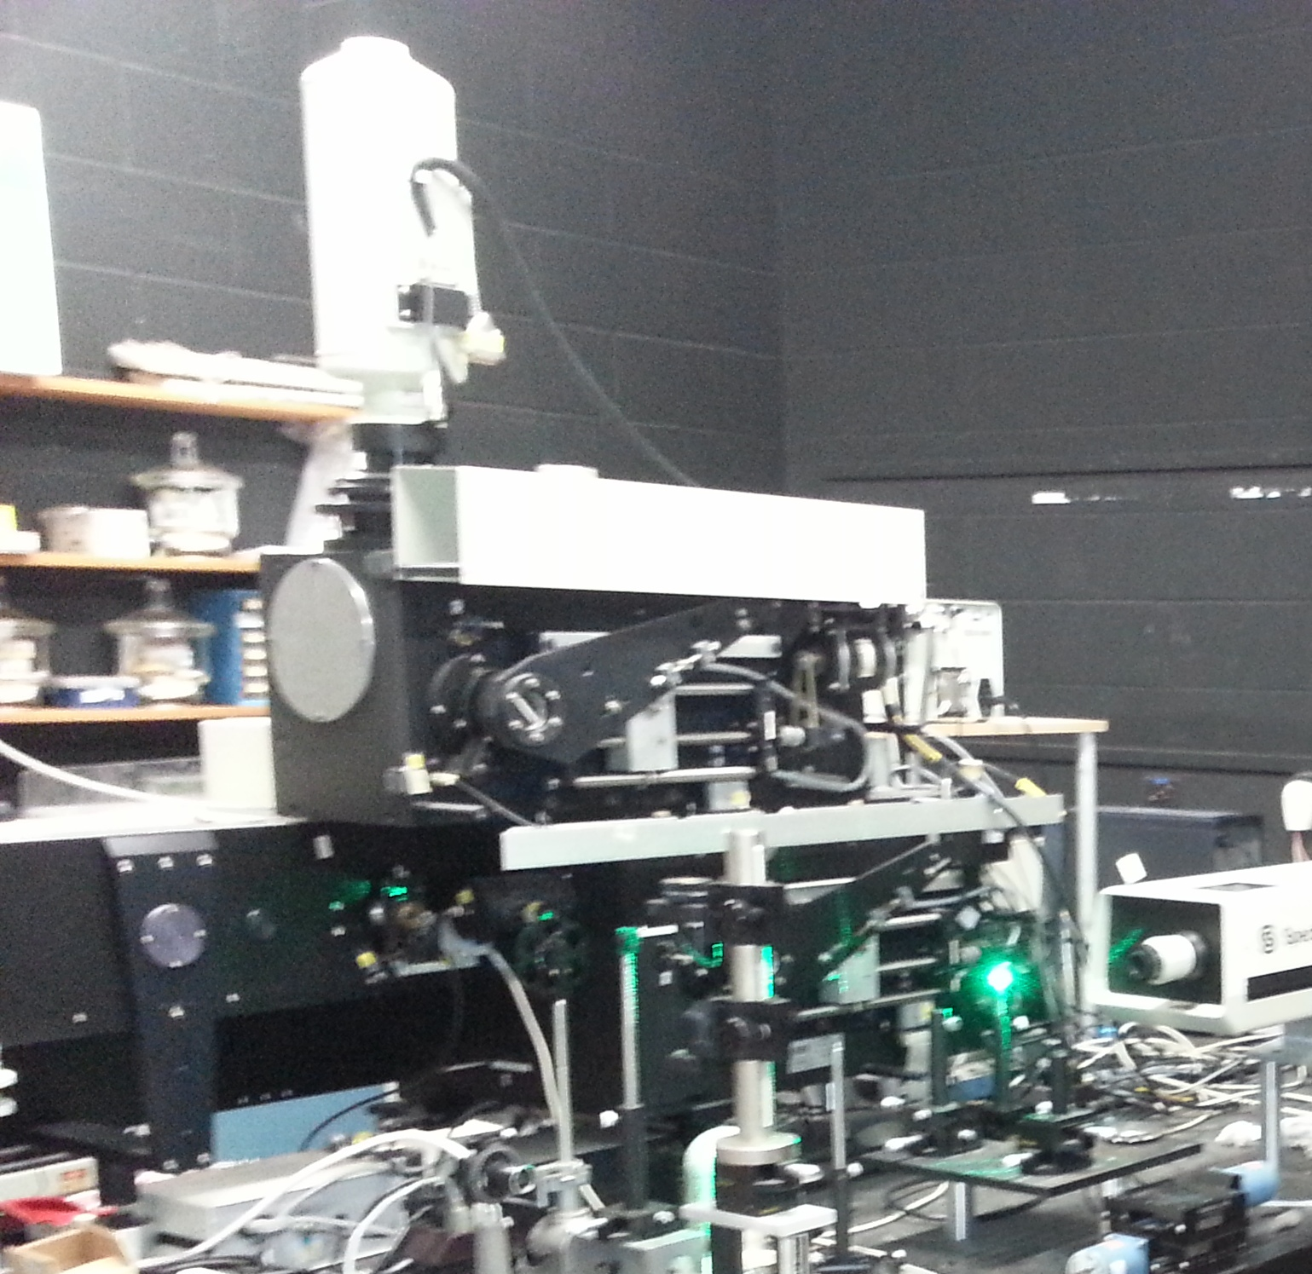
Facilities, Equipment, and Other Resources
Hawaii Institute of Geophysics and Planetology Mineral Physics Lab
The Mineral Physics laboratories at HIGP occupy a space of approximately 3500 sq. ft. and house a wide variety of state of the art analytical instrumentation, majority of which has been acquired over the years with generous help from the NSF EAR programs and has been used for conducting state of the art research and for student training in high-pressure science. The laboratories are equipped for measurements of physical, chemical, spectroscopic, and micro-structural and nano-structural properties of minerals, advanced ceramics and ceramic composites, single-crystalline and poly-crystalline minerals, silicate glasses and melts, and hard thin ceramic films as well as metals and molten alloys. HIGP high pressure labs are not only a truly unique resource for mineral science research and student training within the Hawaiian Islands and central Pacific area, but also one of the largest and most comprehensive academic research facilities in Mineral Physics in the country.
Dilor Raman spectrometer for diamond anvil cell experiments at HIGP.
HIGP currently has five faculty members actively involved in Mineral Physics research (M. Mangnani, S. Sharma, P. Zinin, P. Dera, B. Chen). At the moment there are two Ph.D. students (advisor P. Dera) working on thesis research in Mineral Physics at HIGP. Third student is scheduled to join the group in August 2013 (advisor B. Chen). We hope to extend the group to include another 5-7 students and postdocs over the next five years.
Sample preparation lab
The HIGP Mineral Physics lab is well equipped for sample preparation in mineral science research. The sample preparation labs have just been renovated. Several modern stereo microscopes with long working distance high magnification objectives and high resolution digital cameras offer capabilities for examining, photographing, and documenting the available collection of natural diamond samples. A number of high temperature ovens are available for sample synthesis or removal of moisture from hygroscopic samples.
Raman spectroscopy lab
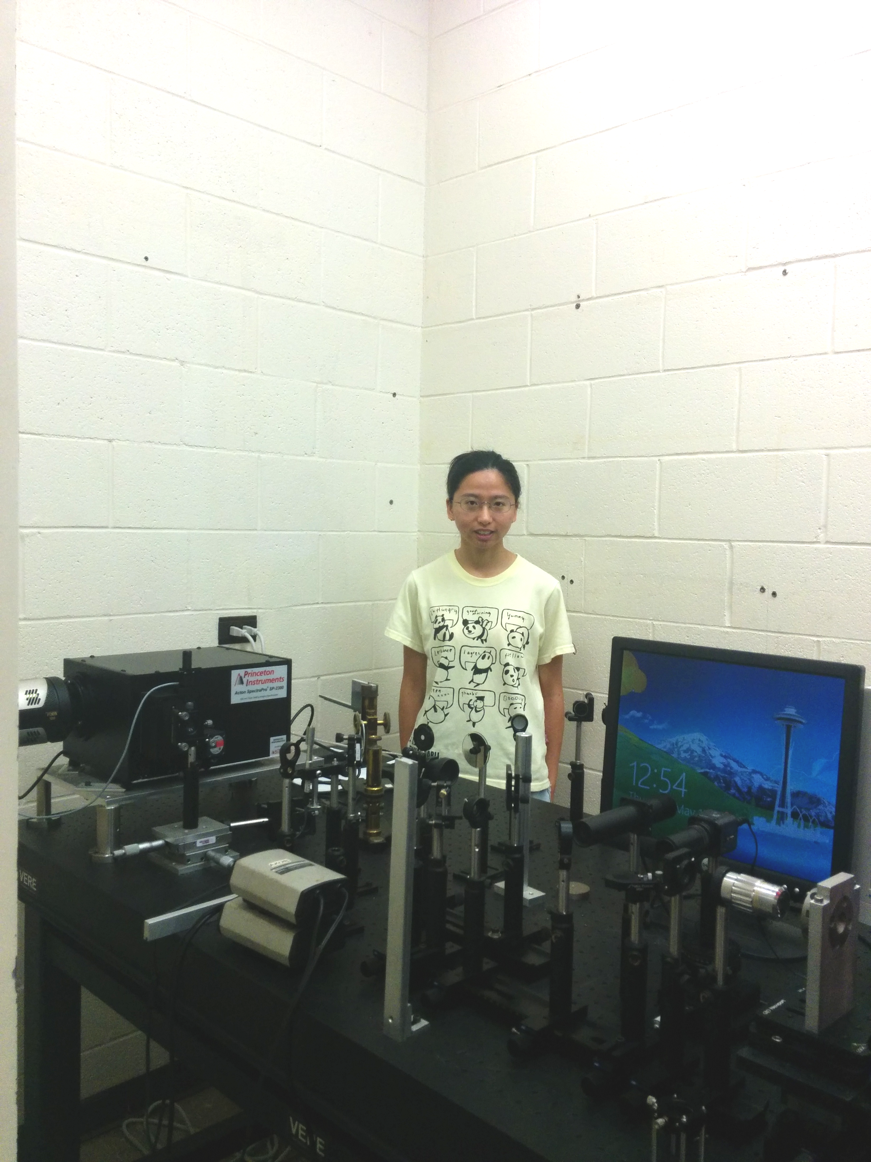
HIGP spectroscopy lab houses a high-resolution triple-grating Dilor Raman spectrometer with a cryogenically cooled CCD detector and long working distance high magnification microscope, optimized for experiments with diamond anvil cells. Spectra Physics Model 2020 Ar-ion laser supplies the incident light. A second custom Princeton Instruments micro-Raman system based on Acton SP2060 imaging spectrograph, thermoelectric deeply depleted back illuminated CCD and 1000 mW 532nm solid state laser has just been added.
UH graduate student in Mineral Physics, Yi Hu (advisor P. Dera) with the new Princeton Instruments micro-Raman spectrometer.
FTIR spectrometer
Supplementary funding from the NSF EAR IF program to the instrumentation grant (PI M. Manghnani) has just been recommended for acquisition of a new Fourier Transform Infrared (FTIR) spectrometer. We are planning to acquire a Vertex 70 FTIR and Hyperion microscope from Bruker Instruments. The FTIR instrument will work in transmission mode in conjunction with an infrared microscope, with minimum aperture windows of ~10 microns, or close to the diffraction limit for mid-infrared light.

